Exercício form006.html

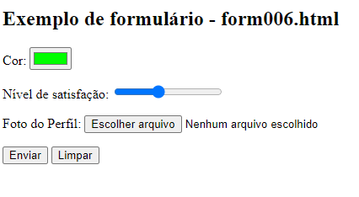

<**body**>

<**h1**>exemplo de formulário form006.html<**/h1**>

<**form** **action**="**cadastro**.**php**" **method**="**get**" **autocomplete**="**on**">

<p>

<**label** **for**="**i_cor**"> **Cor:** </label>

<**input** **type**="**color**" **name**="**cor**" **id**="**i-cor**" **value="#00ff00**">

</p>

<p>

<**label** **for**="**i_nivel**"> **Nível de satisfação:** </**label**>

<**input** **type**="**range**" **name**="**nivel**" **id**="**i_nivel**" **min**="**0**" **max**="**5**" **value**="**2**">

</p>

<p>

<**label** for="**i_foto**"> **Foto do Perfil:** </**label**>

<**input** **type**="**file**" **name**="**foto**" **id**="**i_foto**">

</p>

<p>

<**input** **type**="**submit**" **value**="**Enviar**">

<**input** **type**="**reset**" **value**="**Limpar**">

</p>

</**form**>

</**body**>